1.CREATION OF TABLE CUSTOMER
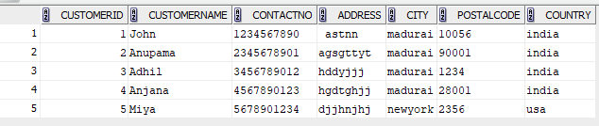
CREATE TABLE Customertabless_details ( CustomerID INT PRIMARY KEY, CustomerName VARCHAR(100), ContactNo VARCHAR(15),Address VARCHAR(150), City VARCHAR(50), PostalCode VARCHAR(10),Country VARCHAR(50));
INSERT INTO Customertabless_details VALUES(1, 'John ', '1234567890', ' astnn', 'madurai', '10056', 'india');
INSERT INTO Customertabless_details VALUES(2, 'Anupama', '2345678901', 'agsgttyt', 'madurai', '90001', 'india');
INSERT INTO Customertabless_details VALUES(3, 'Adhil', '3456789012', 'hddyjjj', 'madurai', '1234', 'india');
INSERT INTO Customertabless_details VALUES(4, 'Anjana', '4567890123', 'hgdtghjj', 'madurai', '28001', 'india');
INSERT INTO Customertabless_details VALUES(5, 'Miya', '5678901234', 'djjhnjhj', 'newyork', '2356', 'usa');
Select * from Customertabless_details;
2.EMPLOYEES
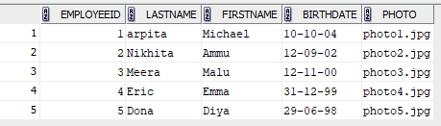
CREATE TABLE Employeestables ( EmployeeID INT PRIMARY KEY,LastName VARCHAR(50),FirstName VARCHAR(50), BirthDate DATE, Photo VARCHAR(100));
INSERT INTO Employeestables VALUES
(1, 'arpita', 'Michael', '10-10-2004', 'photo1.jpg');

INSERT INTO Employeestables VALUES
(2, 'Nikhita', 'Ammu', '12-09-2002', 'photo2.jpg');

INSERT INTO Employeestables VALUES
(3, 'Meera', 'Malu','12-11-2000' , 'photo3.jpg');

INSERT INTO Employeestables VALUES
(4, 'Eric', 'Emma', '31-12-1999', 'photo4.jpg');

INSERT INTO Employeestables VALUES
(5, 'Dona', 'Diya', '29-06-1998','photo5.jpg');
Select * from Employeestables;
3.ORDERS
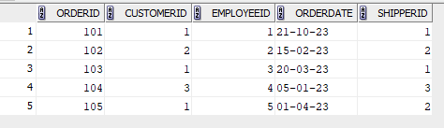
CREATE TABLE Ordering (OrderID INT PRIMARY KEY, CustomerID INT, EmployeeID INT,OrderDate DATE, ShipperID INT,FOREIGN KEY (CustomerID) REFERENCES Customer(CustomerID), FOREIGN KEY (EmployeeID) REFERENCES Employeess(EmployeeID)
);
INSERT INTO Ordering VALUES
(101, 1, 1,'21-10-2023', 1);

INSERT INTO Ordering VALUES
(102, 2, 2, '15-02-2023', 2);

INSERT INTO Ordering VALUES
(103, 1, 3, '20-03-2023', 1);

INSERT INTO Ordering VALUES
(104, 3, 4, '05-01-2023', 3);

INSERT INTO Ordering VALUES
(105, 1, 5, '01-04-2023', 2);
select * from ordering;
- List all customers in ascending order by their names.
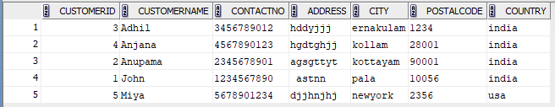
SELECT * FROM Customertabless ORDER BY CustomerName ASC;

- Retrieve a list of orders with the oldest ones appearing first, sorted by order date in ascending order.
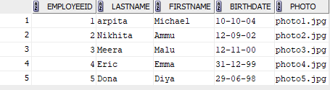
SELECT * FROM Employeestables WHERE BirthDate > '01-01-1980'ORDER BY BirthDate DESC;
- Find the employees who were born after 1980 and list them in descending order of their birthdates.
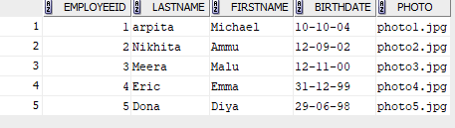
SELECT * FROM Employeestables WHERE BirthDate > '01-01-1980'ORDER BY BirthDate DESC;

- List orders placed by customers from 'USA' in descending order of the order date.
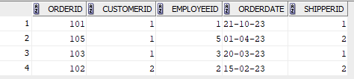
SELECT *
FROM Orders
WHERE CustomerID IN (
SELECT CustomerID
FROM Customer
WHERE Country = 'USA')ORDER BY OrderDate DESC;

- Calculate the total number of orders placed by each customer.
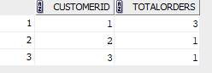
SELECT CustomerID, COUNT(OrderID) AS TotalOrders FROM Ordering GROUP BY CustomerID;
- List the cities with the total number of customers.
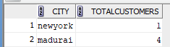
SELECT City, COUNT(CustomerID) AS TotalCustomers FROM Customertabless_details GROUP BY City;

7. List customers who have placed more than 2 orders.
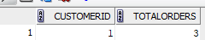.
SELECT CustomerID, COUNT(OrderID) AS TotalOrders
FROM Ordering GROUP BY CustomerID HAVING COUNT(OrderID) > 2;
8.Display cities with more than 3 customers.
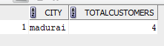
SELECT City, COUNT(CustomerID) AS TotalCustomers
FROM Customertabless_details
GROUP BY City
HAVING COUNT(CustomerID) > 3;

